**Bug Report**

**Write a Bug Report for profile picture not updated in WhatsApp**

**Bug ID :** 01

**Priority** : p1-Medium

**Module** : Profile

**Bug** **Description** : I opened the WhatsApp and go to my profile to edit or update my profile .I just kept a new profile in WhatsApp but it’s not updated.

**Steps** **to** **Reproduce** :

1.Opened the “WhatsApp” .

2.Three dots at the top right corner .

3.Click on the three dots .There will be our profile appeared.

4.Click on the profile picture. There will be a camera option

5.Click on the Camera option. Shows three options like camera,gallery,avatar.

6.Click any one of the option to change or update your profile.

7.By clicking Gallery ,it has many folders.

8.Select the folder you want and select the picture .

9.Once selected picture click save or done .

**Expected** **Result** : The profile picture should update as per the user done.

**Actual** **Result** : Remains the same old profile picture.

**Environment :** Operation System : Windows 10

Browser : Chrome

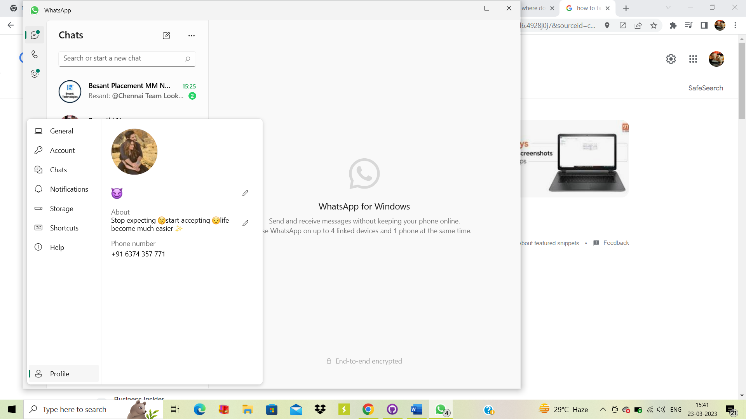**Screenshot :**